EXPT  NO:4A | EXPLORATORY DATA ANALYSIS (EDA) – DATA  INSPECTION, FILTERING, STATISTICAL ANALYSIS  AND CORRELATION

AIM:
To perform data inspection, filtering, grouping, aggregation, descriptive statistical analysis, and correlation analysis using Pandas and visualize the results using Matplotlib.
ALGORITHM:
- Import the required Pandas, NumPy and Matplotlib libraries.
- Read the stud_data.csv file using Pandas.
- Display the dataset and inspect the first few records.
- Find the number of rows and columns and display the data types.
- Generate the statistical summary of the dataset.
- Filter the students based on marks and attendance conditions.
- Sort the student records based on marks and attendance.
- Group the data based on department and calculate average marks and attendance.
- Calculate mean, median, minimum, maximum and standard deviation of marks.
- Calculate the correlation between marks and attendance.
- Create bar chart, line chart, scatter plot, histogram and box plot using Matplotlib.
- Display the results and interpret the obtained data.
PROGRAM:
# Import libraries
import pandas as pd
import numpy as np
import matplotlib.pyplot as plt

# Read dataset
df = pd.read_csv("stud_data.csv")

# Display dataset
print(df)

# Display first five records
print(df.head())

# Display shape
print(df.shape)

# Display data types
print(df.dtypes)

# Display statistical summary
print(df.describe())

# Filter students with marks greater than 80
print(df[df["Marks"] > 80])

# Filter students with attendance greater than 90
print(df[df["Attendance"] > 90])

# Sort students by marks
print(df.sort_values("Marks", ascending=False))

# Sort students by attendance
print(df.sort_values("Attendance", ascending=False))

# Department-wise average marks
print(df.groupby("Department")["Marks"].mean())

# Department-wise average attendance
print(df.groupby("Department")["Attendance"].mean())

# Calculate mean
print("Mean Marks:", df["Marks"].mean())

# Calculate median
print("Median Marks:", df["Marks"].median())

# Calculate minimum
print("Minimum Marks:", df["Marks"].min())

# Calculate maximum
print("Maximum Marks:", df["Marks"].max())

# Calculate standard deviation
print("Standard Deviation:", df["Marks"].std())

# Display correlation matrix
print(df[["Marks", "Attendance"]].corr())

# Display correlation between marks and attendance
print("Correlation:", df["Marks"].corr(df["Attendance"]))

# Bar chart
plt.bar(df["Name"], df["Marks"])
plt.title("Student Marks")
plt.xlabel("Name")
plt.ylabel("Marks")
plt.show()

# Line chart
plt.plot(df["Name"], df["Attendance"], marker="o")
plt.title("Student Attendance")
plt.xlabel("Name")
plt.ylabel("Attendance")
plt.show()

# Scatter plot
plt.scatter(df["Attendance"], df["Marks"])
plt.title("Marks vs Attendance")
plt.xlabel("Attendance")
plt.ylabel("Marks")
plt.show()

# Histogram
plt.hist(df["Marks"], bins=5)
plt.title("Marks Distribution")
plt.xlabel("Marks")
plt.ylabel("Number of Students")
plt.show()

# Box plot
plt.boxplot(df["Marks"])
plt.title("Marks Box Plot")
plt.ylabel("Marks")
plt.show()
OUTPUT:
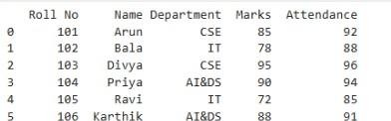
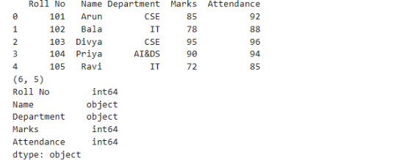
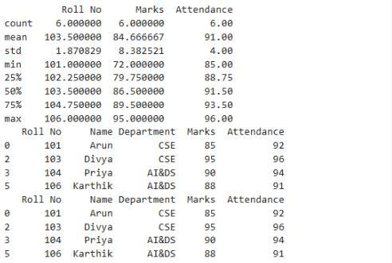
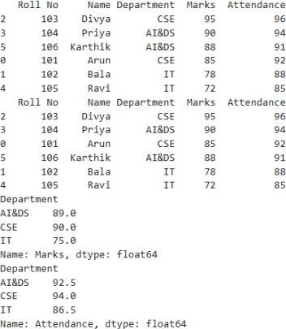
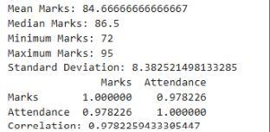
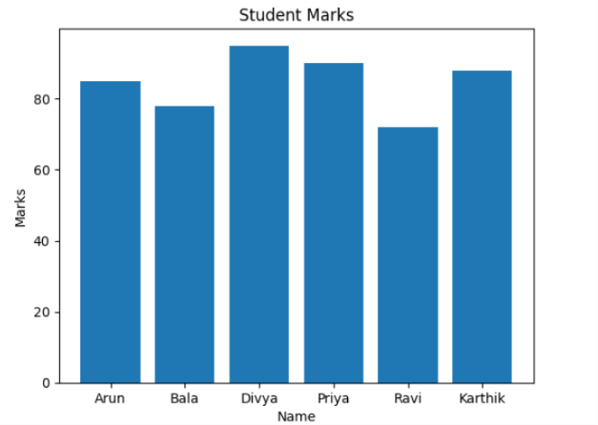
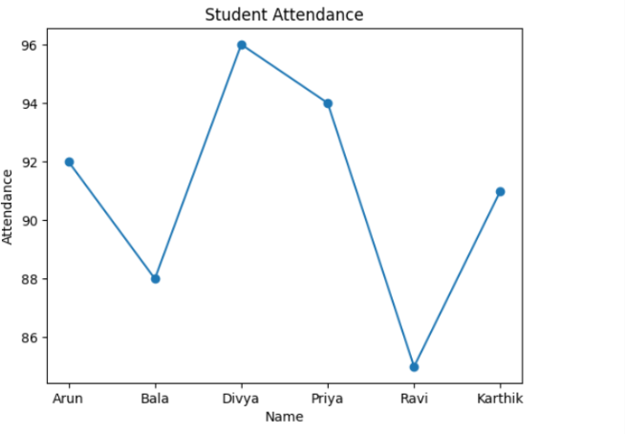
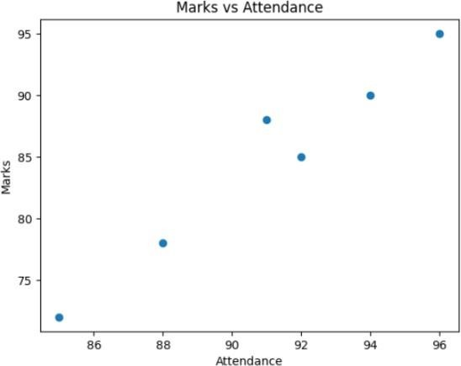
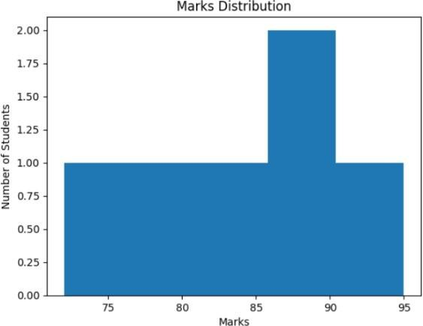
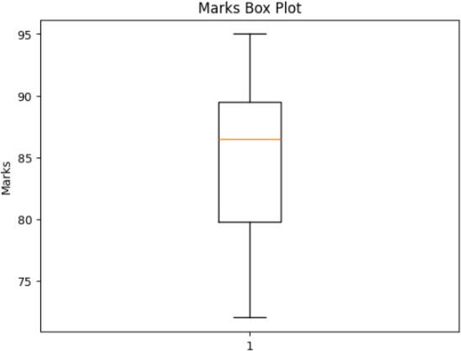
RESULT:
Thus, data inspection, filtering, sorting, grouping, aggregation, descriptive statistical analysis and correlation analysis were performed on the student dataset using Pandas, and the results were visualized successfully using Matplotlib.

EXPT  NO:4B | EXPLORATORY DATA ANALYSIS (EDA) – DATA  INSPECTION, FILTERING, STATISTICAL ANALYSIS  AND CORRELATION

AIM:
To perform data inspection, filtering, sorting, grouping, aggregation, descriptive statistical analysis, and correlation analysis using Pandas and visualize the results using Matplotlib on the Space Mission Dataset (1957–2024).
PROCEDURE:
- Import the required Python libraries.
- Load the Space Mission dataset into a Pandas DataFrame.
- Inspect the dataset by displaying sample records, dimensions, and data types.
- Convert the Datetime column into datetime format and extract Year, Month, Day, and Hour.
- Filter records based on mission status and launch organisation.
- Sort the dataset using mission cost (Price).
- Calculate descriptive statistics such as mean, median, mode, and standard deviation.
- Group the dataset by organisation and calculate the average mission price.
- Perform correlation analysis among numerical attributes.
- Visualize the grouped results and correlation matrix.
- Interpret the obtained analytical results.
OUTPUT:
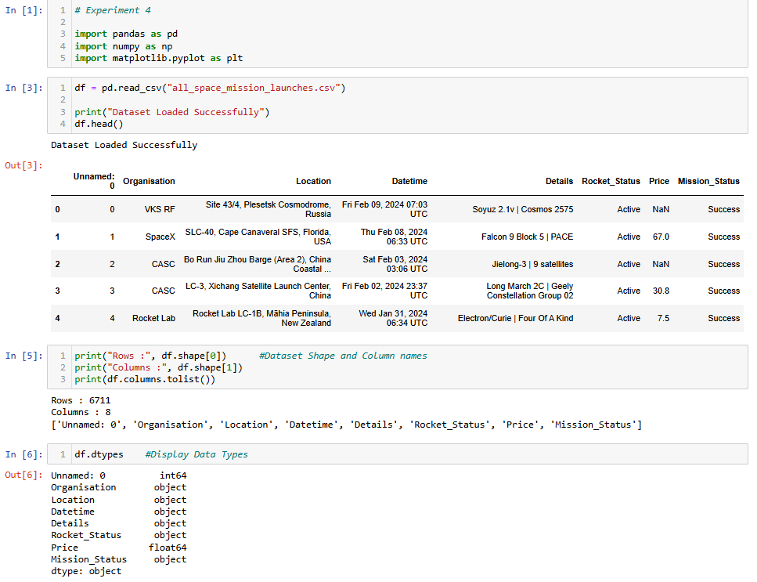
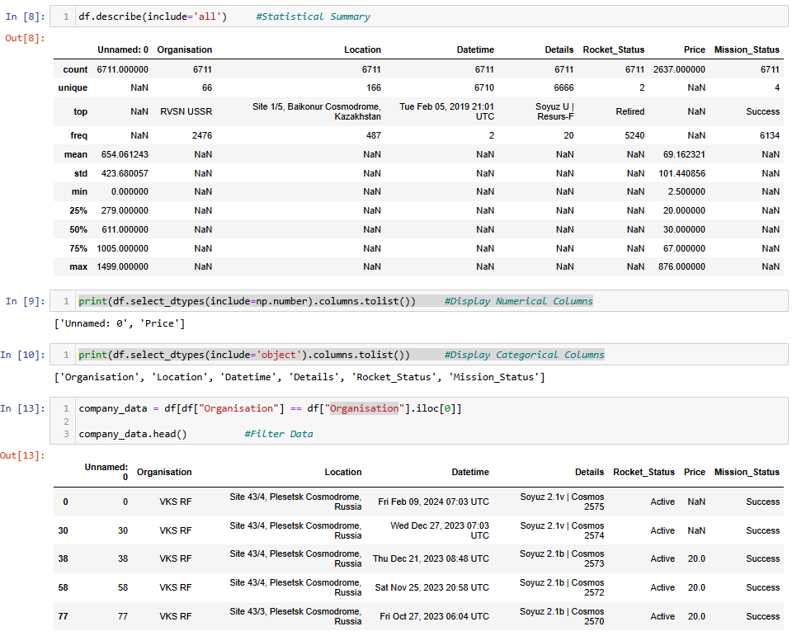
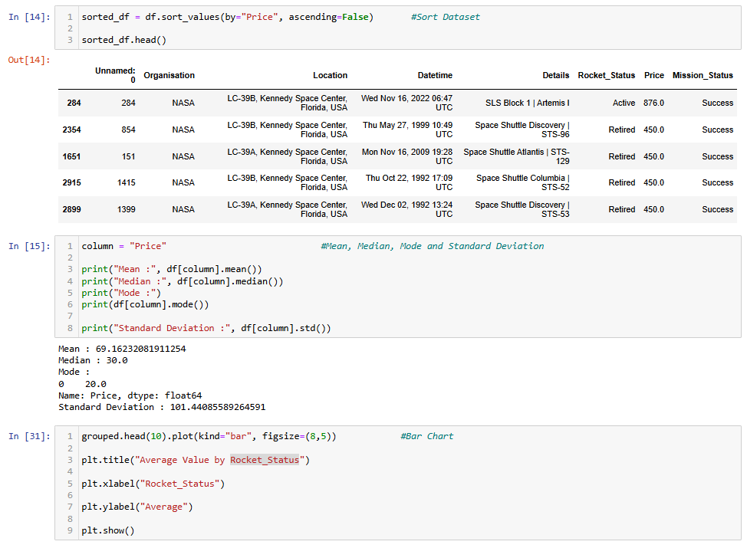
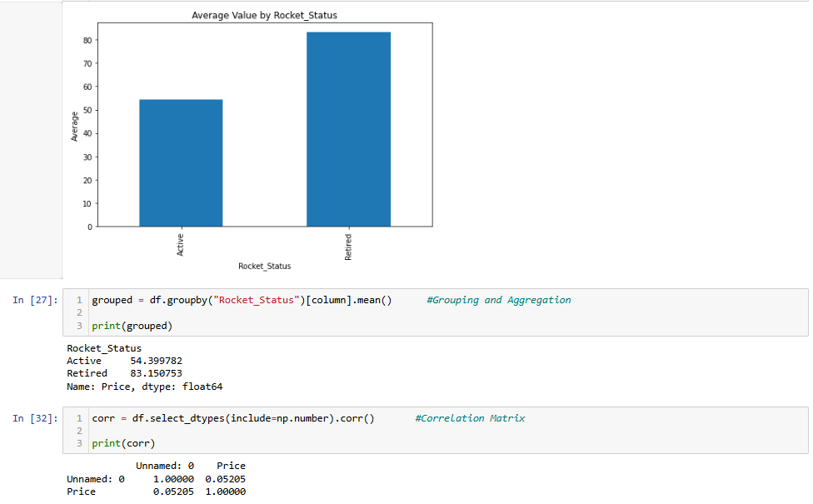
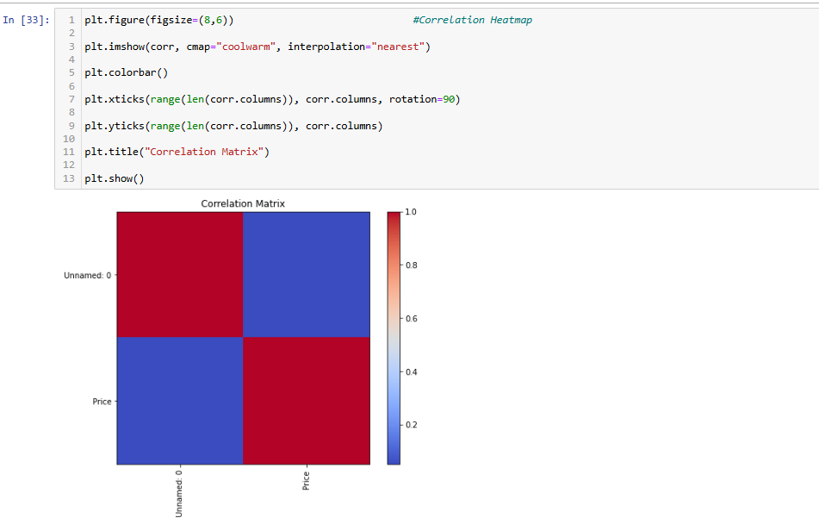
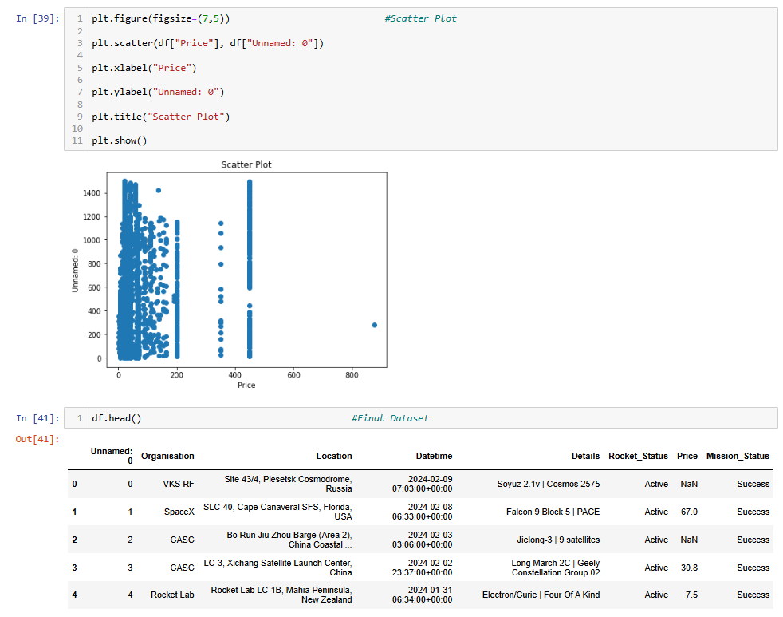
RESULT:
Thus, data inspection, filtering, sorting, grouping, aggregation, descriptive statistical analysis and correlation analysis were performed on the Space Mission dataset using Pandas, and the grouped results and correlation matrix were visualized successfully using Matplotlib.

